Title: Chat component for Liferay 7

As a first step we need to configure Apache directory server for LDAP if that setup is not already exists. LDAP will be needed in order to use common user for Open Fire and Liferay.

**Configure Apache Directory Server for LDAP:**

Setup of Apache Directory server

* Install Apache Directory Studio from <http://directory.apache.org/studio/downloads.html>
* Once installation is done open it
* Now you have to configure LDAP server
* Right click on LDAP Servers area and select New -> New Server.

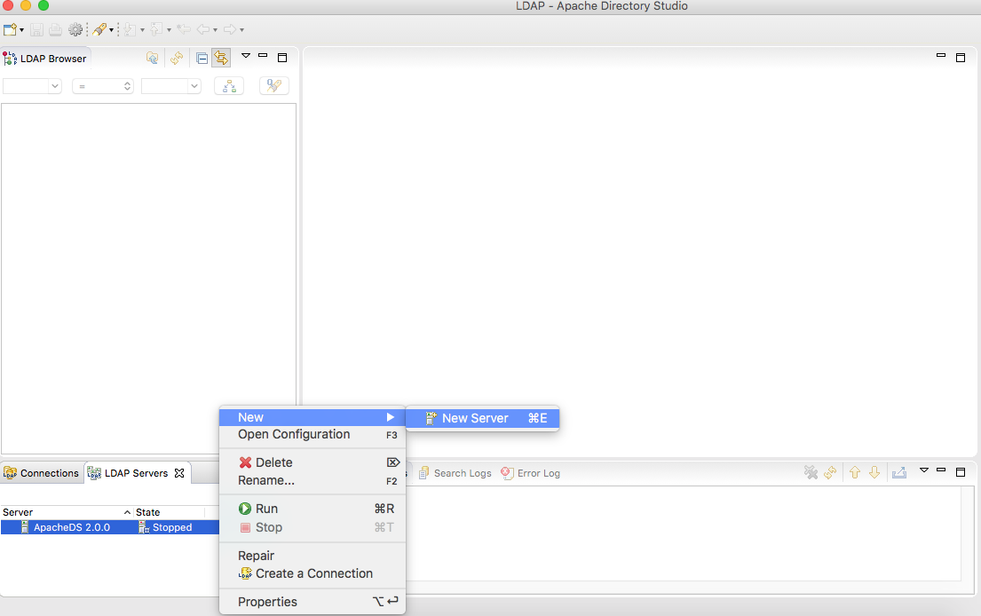

* You will get dialog where you need to select Apache DS 2.0.0 and click on Finish

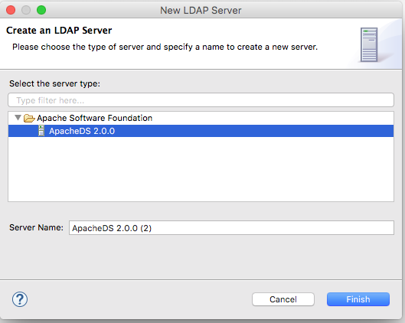

* You can get server created in LDAP Servers area. Right click on it and start the server.
* Once your LDAP server is started, you can create connection in Connections area.
* Right click on Connections area and then select New Connection

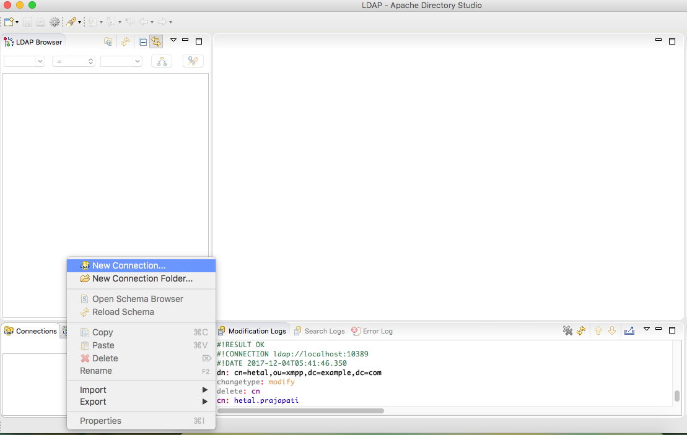

* Add connection name, host and port for your LDAP server and click on Next

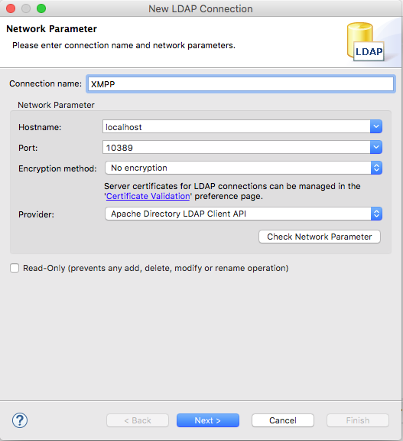

* Add Base DN and Password information by selecting Simple Authentication method and click on Finish. Password for LDAP is secret by default.

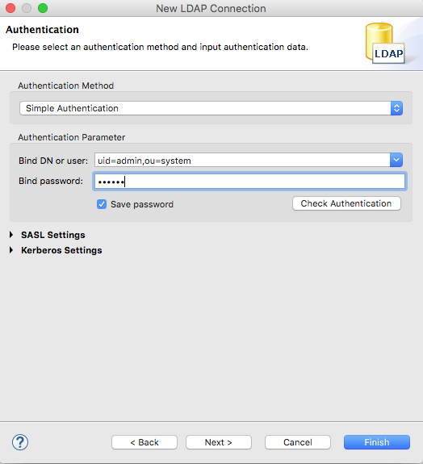

* If you LDAP is started properly then your connection will be successful.
* Once your connection is successful you need to create ou(organizationUnit) in LDAP.
* Right click on dc=example,dc=com property and select New-> New Entry option

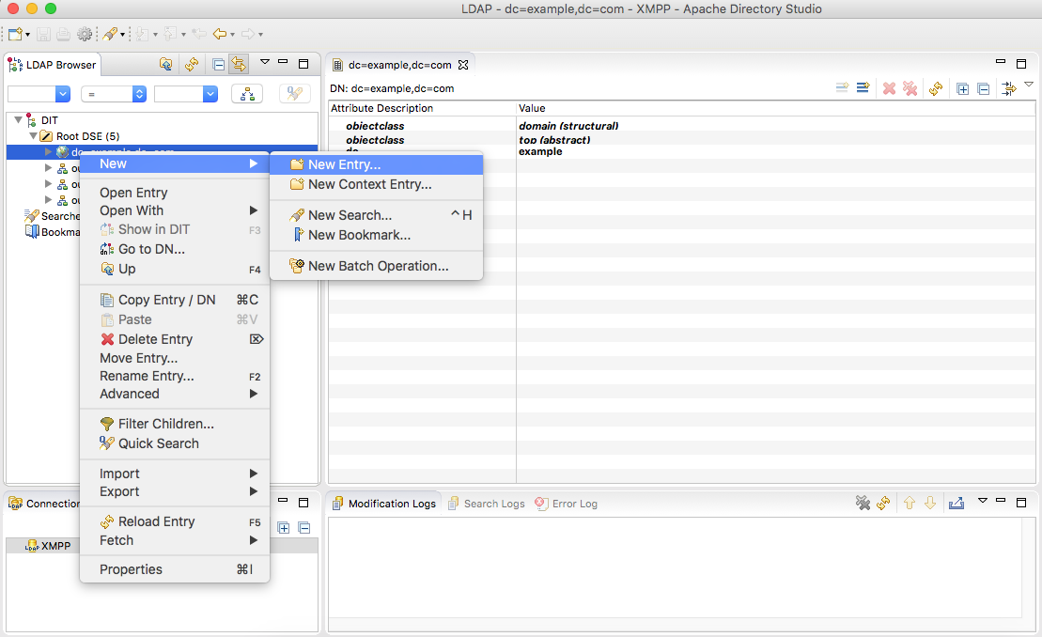

* Select "Use existing entry as a Template" on New Entry dialog box and click on Next.

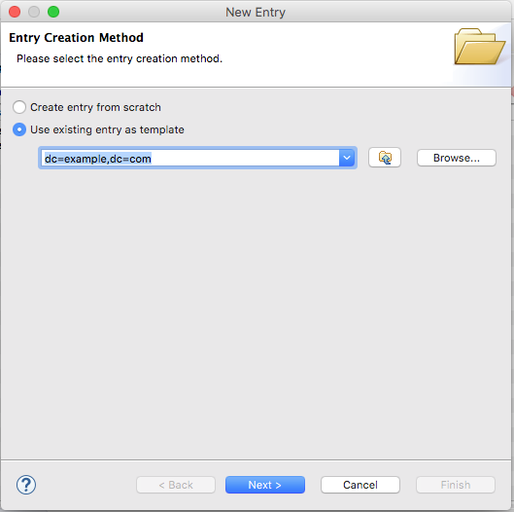

* Now add O in search area for add component and you will organizationlUnit add that option and remove domain option and click on Next

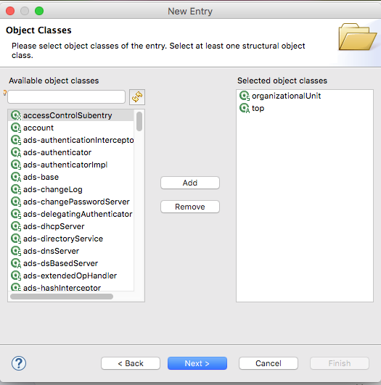

* Select Parent as dc=example,dc=com and add RDN information and click on Next

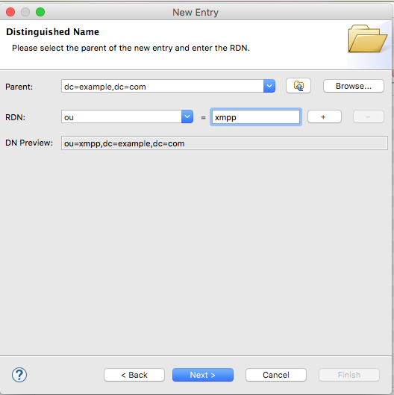

* Your Entry is created and shown to you for final step. Click on Finish button.

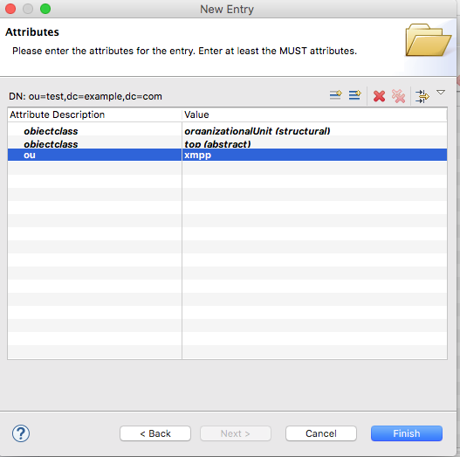

* Your LDAP setup is completed. Now you can use your LDAP server in Liferay as well open fire.

We are done with setting up LDAP now we will use this LDAP server details in Liferay for LDAP integration

**Configure Liferay :**

* Install vanilla Liferay 7.
* Start Liferay server.
* Login with Administrator and go to Control Panel -> Instance setting -> Authentication -> LDAP ->  Click on Add LDAP Server.
* Add respective LDAP server configurations.  For reference check below.

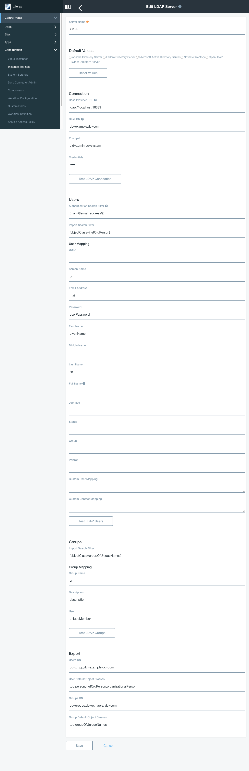

* Liferay LDAP field name and Openfire User mapping field name must match here I took Liferay user screen name as cn for LDAP and same in Openfire LDAP.
* Click on Save button.

Liferay is connected with LDAP now we can see all the users of LDAP in Liferay. We will use same LDAP server in configuring Openfire with LDAP.

**Configure Openfire Server :**

* To setup openfire Liferay and LDAP setup should be done successfully as openfire setup will need atleast 1 user to be exported in LDAP who can be added as admin.
* If you don’t have Openfire setup installed already then please go to its official site and follow instructions.

<https://www.igniterealtime.org/projects/openfire/documentation.jsp>.

* If openfire is already installed with default settings then you need to configure it with LDAP. Please follow below steps.
  + Stop openfire.
  + Open /conf/openfire.xml file
  + Set <setup>false</setup>
  + Start Openfire.
* Openfire server default start on 9090 port. You can access admin console with <http://localhost:9090>.
* Once you start openfire, it will open admin console where you can set properties like database, language, ldap, etc.
* First step will be set language.   
    
  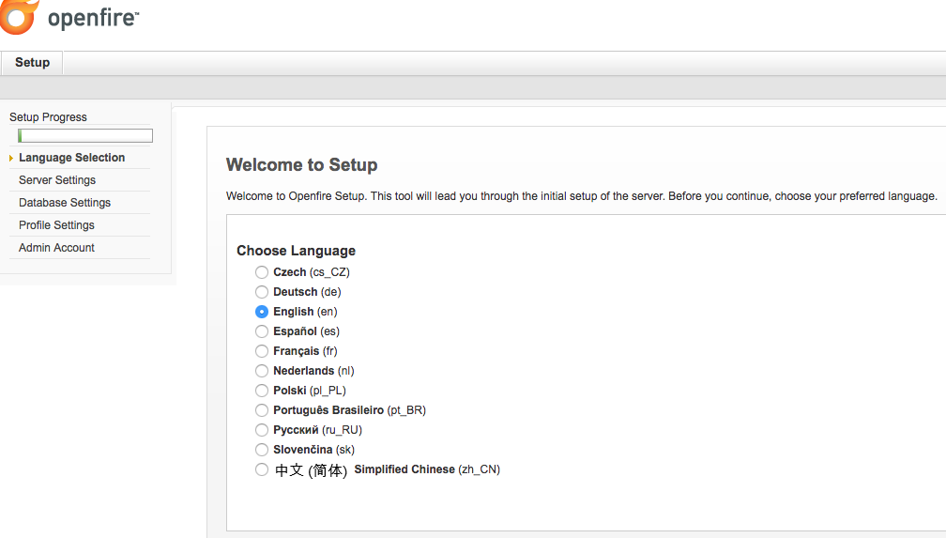

* Second step will be to setup server host detail.

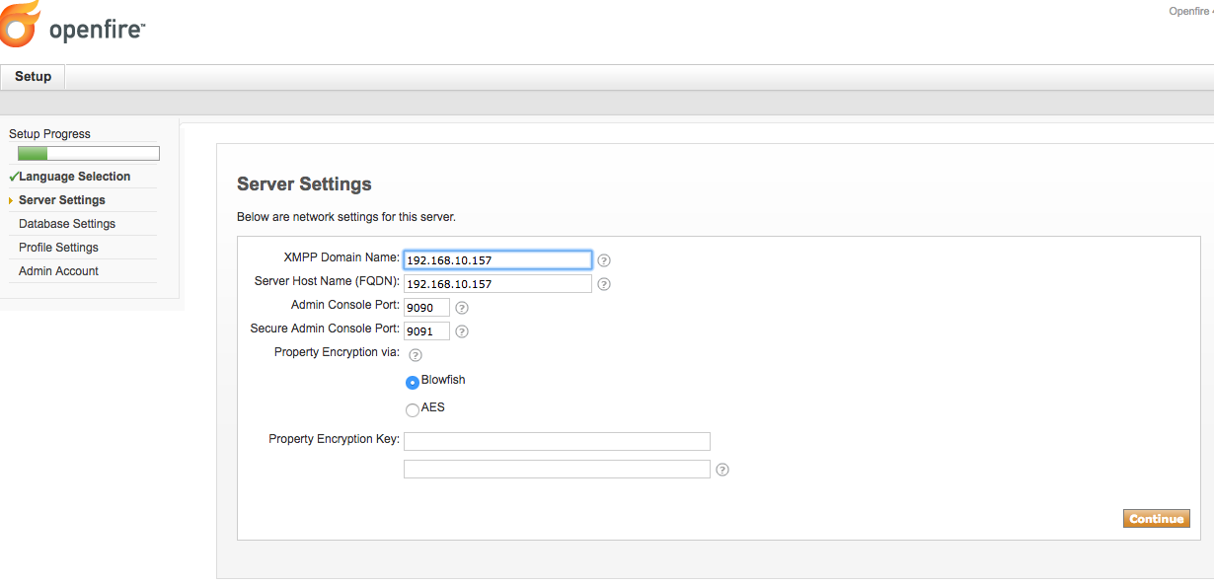

* Third Step will be to setup database details.

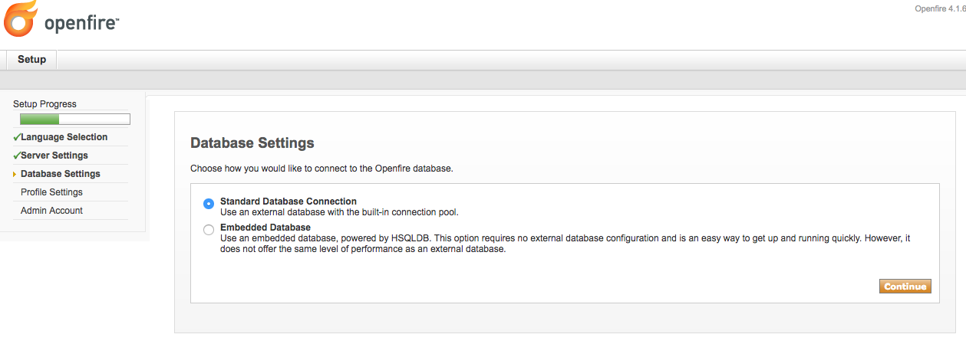

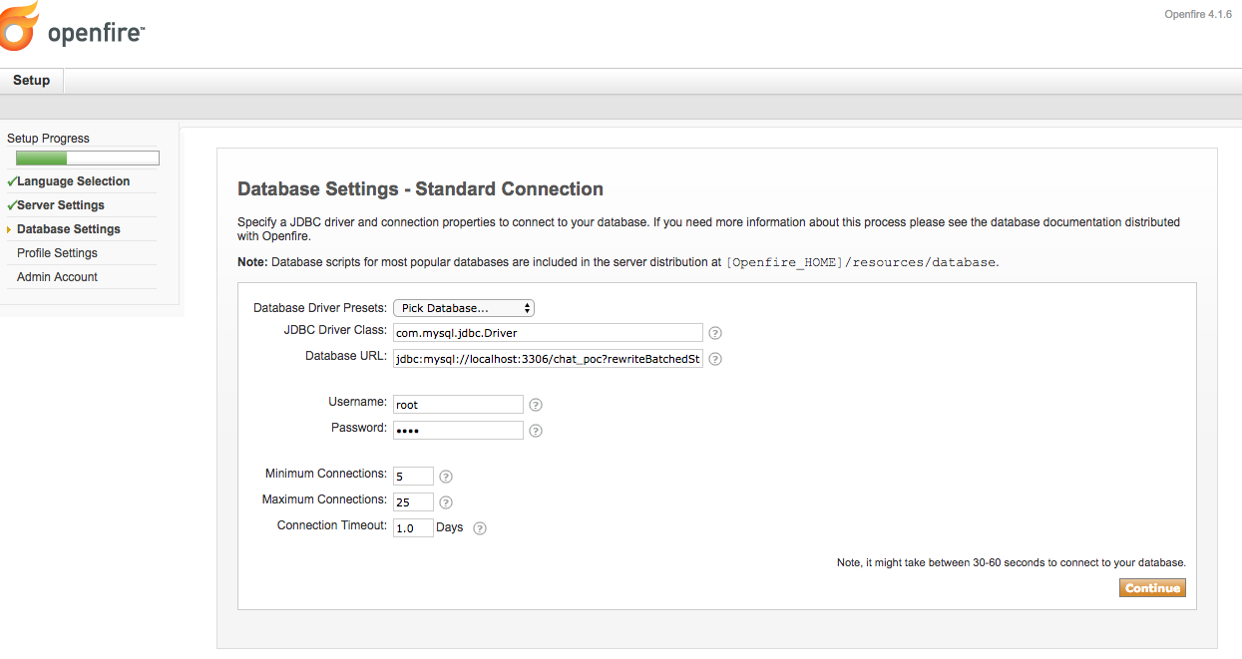

* Fourth step will be for profile setting.
* Now its time to do configuration of LDAP server, Here I have selected Directory server.

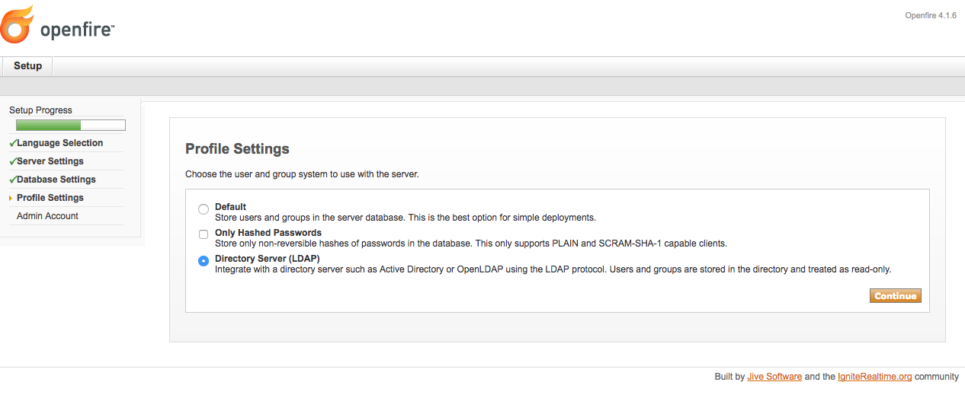

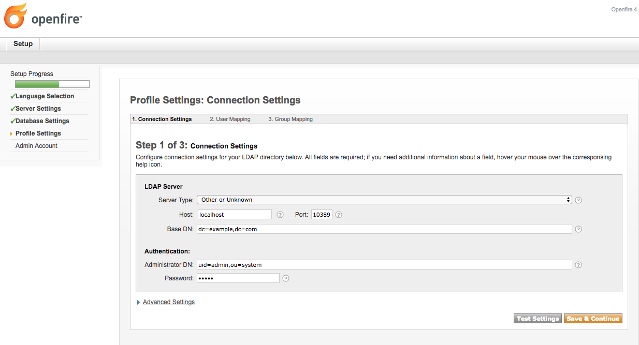

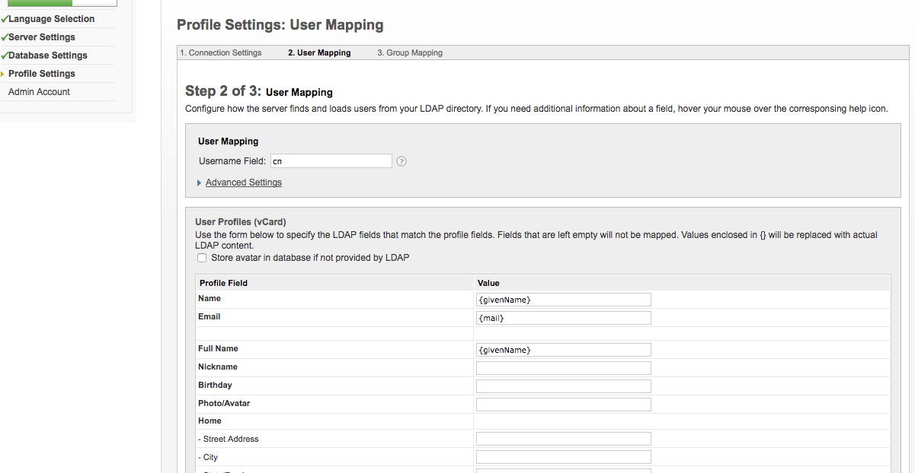

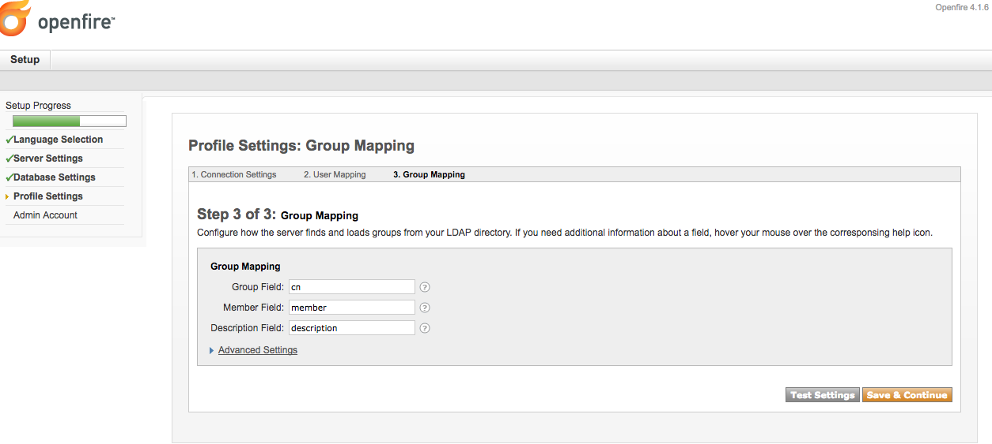

* Fifth step is set up admin account.

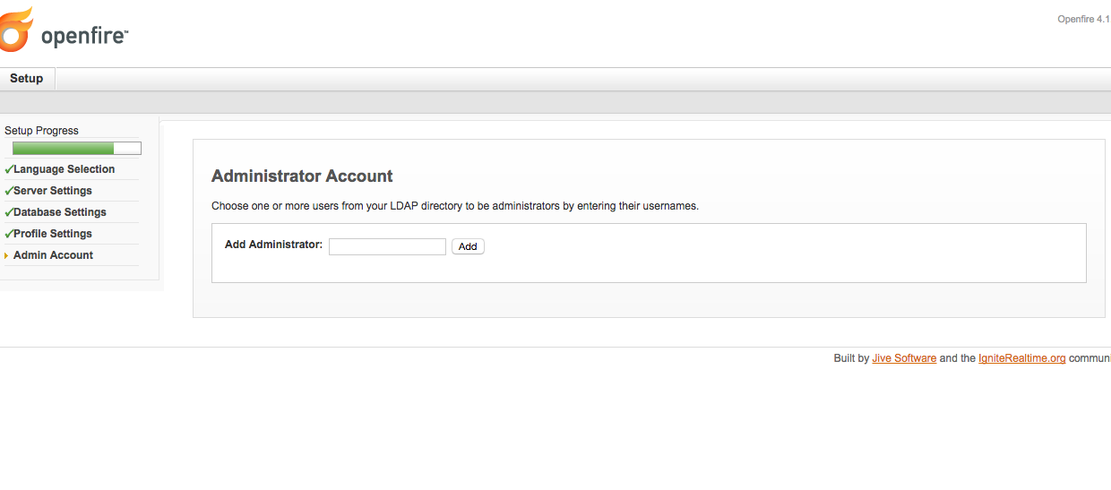

* Finish the set up of Openfire and login again in admin console.
* Once you login with admin console then you can setup http-bind setting in server settings.

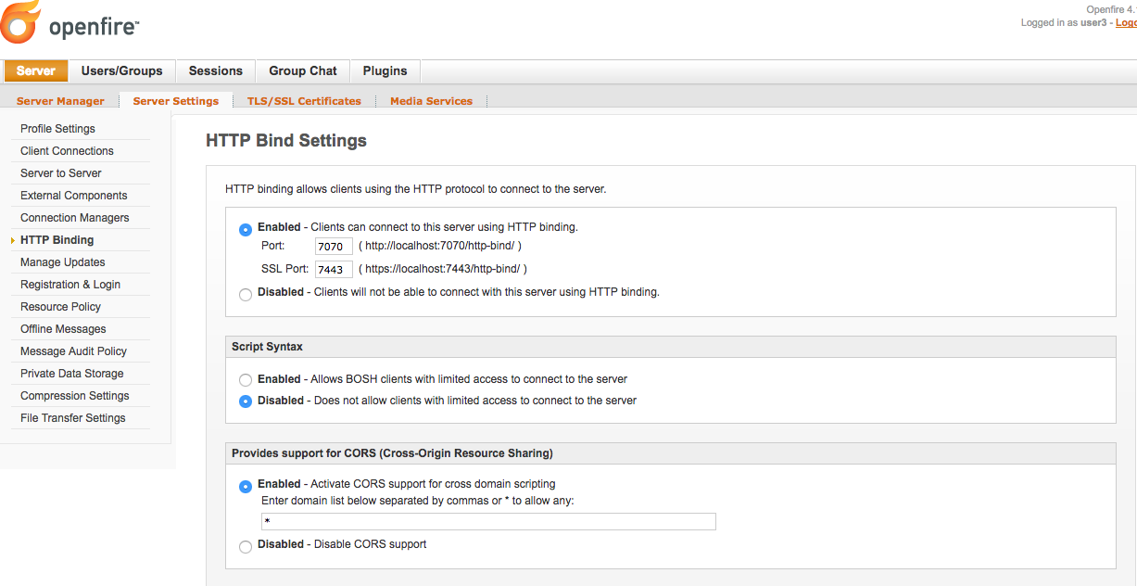

* In order to use rest APIs of open fire, we need to install rest-api plugin.
* Go to plugnis -> Available Plugins -> Find REST API  plugin and click on '+' icon. Open fire will install REST API plugin.
* Go to Server -> Sever Setting -> REST API -> Checked radio button "**Enabled** - REST API requests will be processed" and Checked "Secret key auth - REST API authentication over specified secret key." radio button and copy Secret key and put it in portal-ext.proerties file with propertyname as "xmpp.openfire.rest.auth.token"
* In order to start chatting we need to create atleast one group in openfire.
* Login into admin console.
* Go to Group Chat tab.
* Click on Create New Room



* Enter all the details related to room in form



* Click on Save Changes.

Now our Openfire, LDAP and Liferay setup is done. We are ready to install Chat component into Liferay 7.

• Add below properties in portal-ext.properties.

* xmpp.openfire.rest.url=<http://localhost>
* xmpp.openfire.rest.port=9090
* xmpp.openfire.rest.auth.token=nB5mJ11Q0yE4vR3v [Note: This value you can get from Openfire admin console and mentioned in Openfire setup]
* xmpp.hostname=localhost
* xmpp.domain.name=localhost
* xmpp.http.bind.port=7070
* Restart Liferay Sever after putting portal-ext.properties file.
* Deploy chat component in Liferay.
* Go to any Site and create one page.
* Drop Chat Web Module in page.
* Logout from current user.
* Login in again in the portal. [ This steps require because we are getting user's String password at Login time.]
* Go to Chat page and if User is successfully exported to LDAP and authenticated by Openfire then you can connect Chat.
* For testing, create new User in Liferay and Log in with that user in other browser and start conversation with Other users.